DataKlicks Hub — Complete Website Product Requirements Document (PRD)
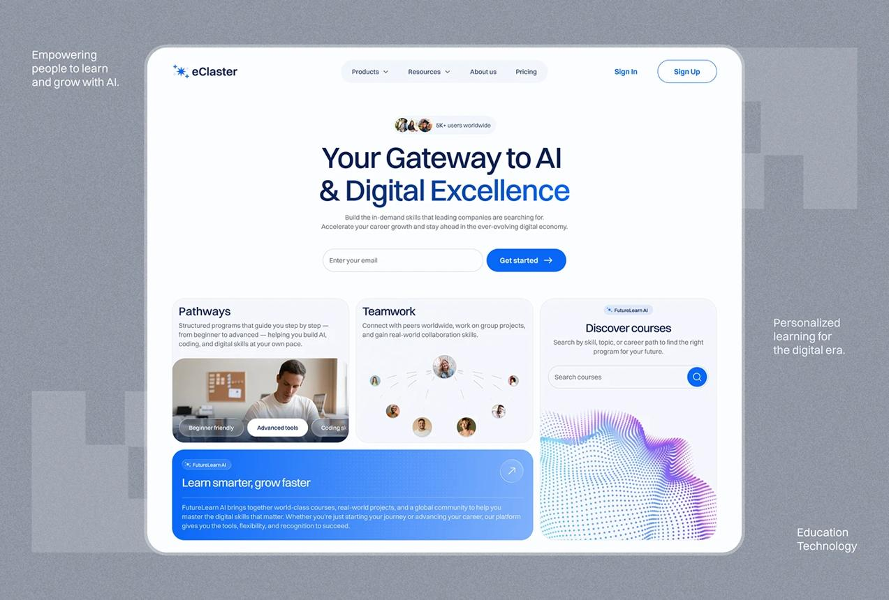
Website PRD
Version 1.0
Corporate + EdTech


DataKlicks Hub
Building Skills. Creating Opportunities. Driving Digital Impact.
Brand tagline: Raising the Top 1% Tech Giants in Africa.

1. Product overview

1.1 Product name
DataKlicks Hub

1.2 Product type
A premium, responsive corporate website combining:
- Technology and AI education.
- Data analytics and business analytics training.
- Professional development and digital skills.
- Business consulting and technology solutions.
- Educational content, thought leadership and impact storytelling.
- Course discovery, lead generation and business partnerships.

1.3 Product vision
To establish DataKlicks Hub as a trusted African technology education and business solutions brand, connecting individuals to future-ready skills and helping organizations translate data, AI and technology into measurable business value.

1.4 Website objectives
The website must:
- Establish a credible, internationally presentable brand.
- Convert visitors into course enquiries, training registrations and consulting leads.
- Clearly communicate the company's evolution from a data analytics training startup into a broader technology and business solutions company.
- Showcase verified achievements, learner impact, media features and community initiatives.
- Attract corporate clients, schools, NGOs, development organizations, employers and strategic partners.
- Create a central digital home for courses, blogs, events and educational resources.
- Support future expansion into online learning, AI products, automation solutions and digital communities.

1.5 Core positioning
DataKlicks Hub is a technology, education and business solutions company building the next generation of data and AI professionals while helping businesses use technology, data and digital solutions to grow.
The website must communicate both sides of the business: developing people and enabling businesses.

2. Brand identity and design direction
Royal Blue
Primary brand colour
#2346D3
White
Primary background
#FFFFFF
Midnight Navy
Headings and dark sections
#0B1220
Soft Blue-White
Section backgrounds
#F4F7FF
The exact royal blue can be adjusted to match the existing DataKlicks Hub logo.

Visual direction
The website should feel like a combination of a modern international technology company, a premium professional learning platform and a credible African innovation organization.
Design characteristics:
- Clean, spacious layouts with strong visual hierarchy.
- Large typography and concise, confident headlines.
- Royal blue calls to action against white backgrounds.
- Subtle gradients, abstract data visualizations and AI-inspired graphics.
- Professional photography of African learners, instructors, teams and business environments.
- Custom illustrations or diagrams for analytics, AI and automation.
- Smooth scrolling, tasteful motion and interactive statistics.
- Consistent rounded cards, buttons, icons and spacing.
- High-quality mobile navigation and touch-friendly controls.
Avoid excessive gradients, generic AI-generated imagery, unnecessary animations, crowded sections, distracting effects and template-like layouts.

Typography
Recommended font pairing:
- Headings: Manrope or Plus Jakarta Sans.
- Body: Inter.
Use a consistent type scale, accessible contrast, comfortable line spacing and readable text sizes across devices.

3. Target audience and user personas
The website must serve several audiences without making the brand appear scattered.

Persona 1: Aspiring tech professional
Students, graduates, career switchers and working professionals.
Wants accessible training, practical projects, mentorship, portfolio development and career guidance.
Primary CTA: Explore Courses

Persona 2: Business owner or startup founder
SMEs, entrepreneurs and growing businesses.
Wants better reporting, business intelligence, automation, data-driven decisions and operational efficiency.
Primary CTA: Get Business Support

Persona 3: Corporate decision-maker
HR managers, L&D teams, executives and department heads.
Wants employee upskilling, customized corporate training, reporting capabilities and measurable outcomes.
Primary CTA: Request Corporate Training
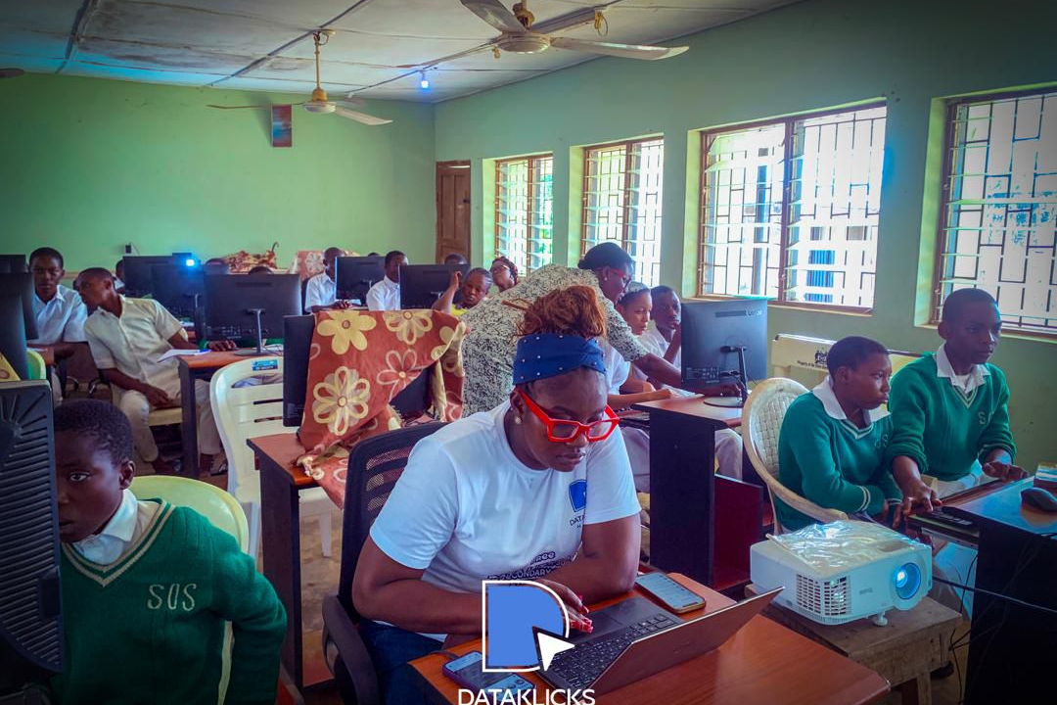
Persona 4: Institutional and impact partner
Schools, NGOs, foundations, government agencies and sponsors.
Wants credible impact evidence, partnership opportunities, transparent project information and reporting.
Primary CTA: Partner With Us

4. Website architecture and sitemap
The primary navigation must contain the five requested pages: Home, Courses, About Us, Blog and Contact.
Additional pages should support the main website without overcrowding the navigation.
DataKlicks Hub
Home
/
Courses
/courses
Course details
/courses/slugslug
About Us
/about
Impact & Partnerships
/impact
Business Solutions
/business-solutions
Blog
/blog
Blog article
/blog/slugslug
Contact
/contact
Privacy Policy
/privacy-policy
Terms of Use
/terms
Cookie Policy
/cookie-policy
The impact and business solutions pages may initially be sections within the About and Contact pages, but the architecture should allow them to become standalone pages.

5. Global website requirements
These requirements apply to every page.

5.1 Header and navigation
- Display the DataKlicks Hub logo on the left.
- Include Home, Courses, About Us, Blog and Contact.
- Add a prominent “Explore Courses” button.
- Use a sticky header that remains accessible while scrolling.
- Provide a mobile hamburger menu with keyboard and screen-reader support.
- Highlight the current page.
- Include a clearly visible focus state for keyboard navigation.

5.2 Footer
The footer must contain:
Brand section
DataKlicks Hub
Raising the Top 1% Tech Giants in Africa.
Quick links
Home, Courses, About Us, Blog, Contact.
Learning
Data Analytics, Business Analytics, AI & Automation, Corporate Training.
Company
About Us, Impact Projects, Business Solutions, Partnerships.
Contact
- Email: dataklickshub@gmail.com
- Location: Lagos, Nigeria
- Website: www.dataklickshub.com
Social media
- LinkedIn: DataKlicks Hub
- Instagram: @dataklicks_hub
- Facebook: DataKlicks Hub
Include copyright information, privacy policy, terms of use and cookie preferences.
The Instagram and Facebook URLs should be confirmed before launch. Do not link social icons to unverified accounts.

6. Home page — detailed requirements
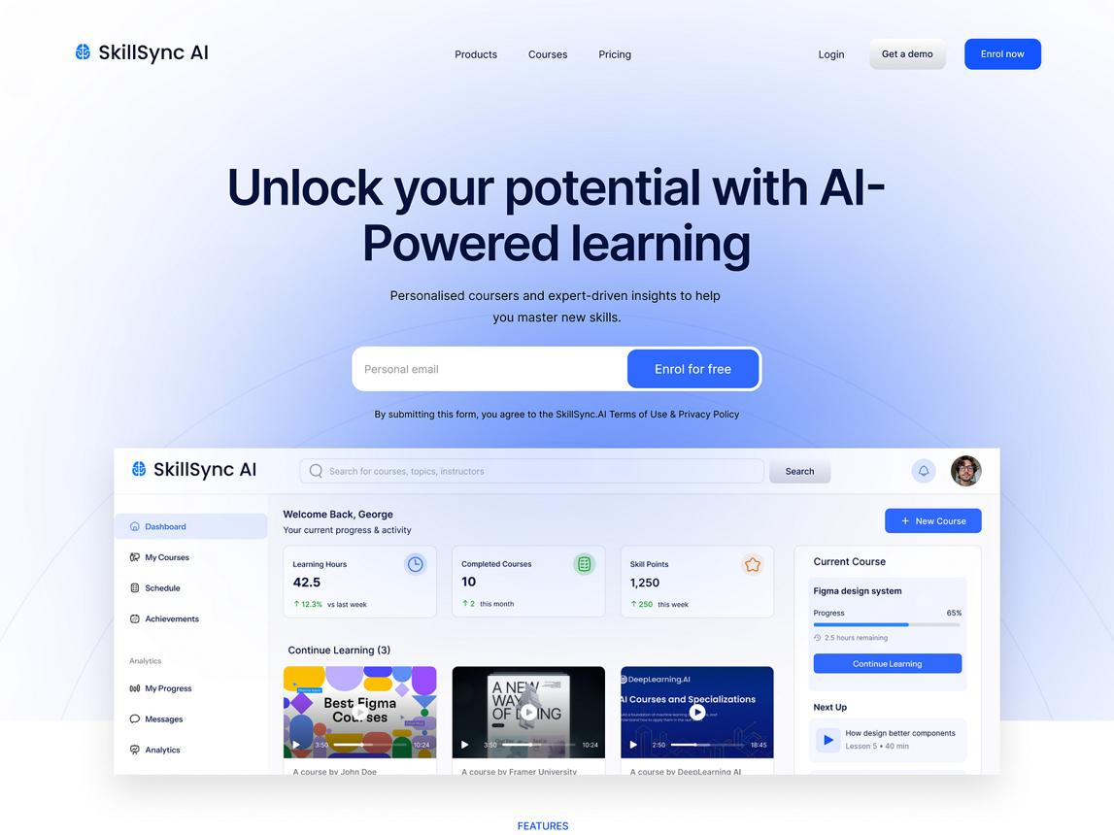
The home page must communicate what DataKlicks Hub does, who it serves, its credibility and the next step a visitor should take within the first few seconds.

Section 1: Hero
Technology • Education • Business Solutions

Building Africa’s Next Generation of Data and AI Professionals.
We equip individuals with practical digital skills and help businesses turn data, AI and technology into opportunities for growth.
Data Analytics
Artificial Intelligence
Business Solutions
Explore Our Courses →
Work With Us
Visual reference for layout and messaging. This is not the finished website.
Primary headline:
Building Africa’s Next Generation of Data and AI Professionals.
Supporting copy:
DataKlicks Hub is a technology, education and business solutions company helping individuals develop future-ready skills and enabling businesses to grow through data, AI and digital innovation.
Primary CTA: Explore Our Courses
Secondary CTA: Partner With Us
Hero visual: A custom illustration combining data dashboards, AI interfaces, code elements and an African professional learning environment.
Interaction: A subtle animated data visualization or floating interface elements. Animation must not interfere with text readability or accessibility.

Section 2: Trust and credibility
Display a slim credibility strip below the hero.
Potential elements:
- Founded in 2023.
- Lagos, Nigeria.
- Featured in Tribune Online.
- Data analytics and AI education.
- Women and girls in technology initiatives.
Use only confirmed partnerships, awards, certifications and media logos. Do not imply that a publication endorses the company merely because it covered an initiative.

Section 3: Animated impact statistics
Use large animated numbers that count up when the section enters the viewport.

5,000+
People trained or impacted
Publish after verifying the consolidated total.

3,000
Secondary school students
Digital and data skills initiative.

80%+
Women reached
Publish only with supporting records.

2023
Year founded
Company milestone.
Implementation rules
- Animate numbers only when they enter the viewport.
- Respect the user's reduced-motion preference.
- Include the final value in the accessible page content.
- Do not continuously loop the animation.
- Never display unverified figures as established facts.
The Africa metric should be represented as a geographic or mission statement rather than a numerical statistic.

Section 4: What we do
Headline: Skills, Technology and Solutions for a Digital-First World.
Present six service cards.
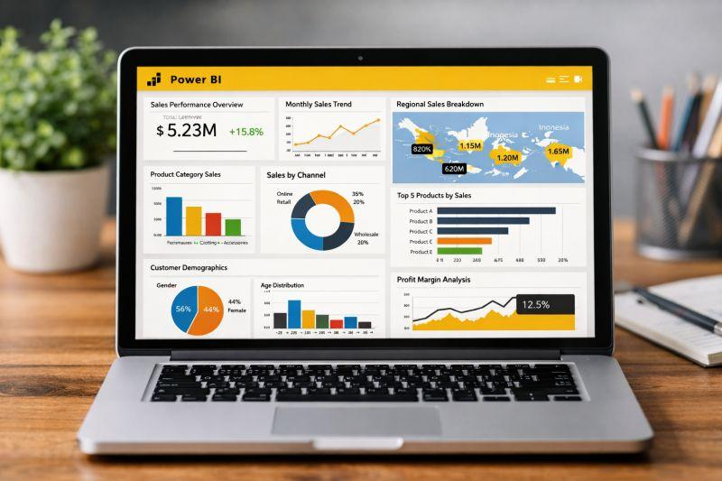
01. Data Analytics & Business Intelligence
Learn to clean, analyze, visualize and interpret data using Excel, Power BI, SQL, Tableau and Python.
Explore Data Analytics →

02. Artificial Intelligence
Build practical AI literacy and learn how to apply AI tools to professional and business workflows.
Explore AI Training →

03. Generative & Agentic AI
Explore generative AI, prompt design, AI-assisted workflows and systems that can execute multi-step tasks with appropriate oversight.
Explore AI Programs →
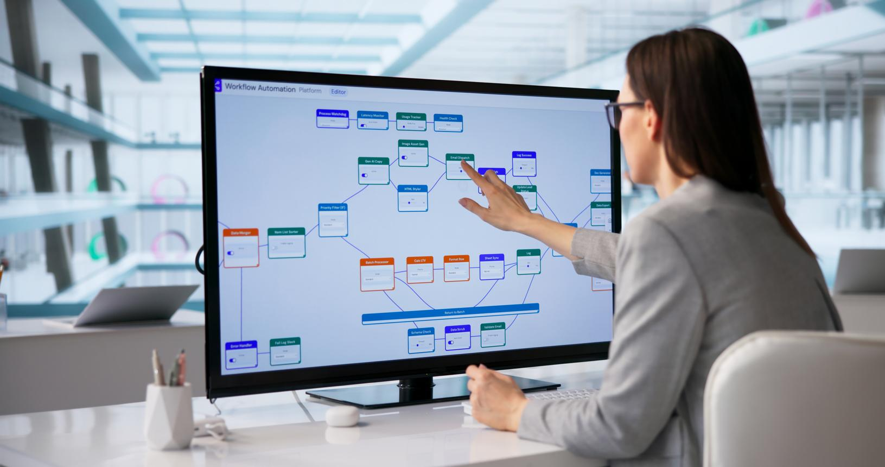
04. AI & Automation
Discover workflow automation, process improvement and opportunities to reduce repetitive work.
Explore Automation →

05. Business Consulting
Support for business strategy, operations, analytics, process improvement and data-informed decisions.
Our Business Solutions →

06. Digital & Professional Skills
Build digital confidence, communication, critical thinking, problem-solving and workplace readiness.
Discover Our Programs →
Each card must link to a relevant course category or service detail page.

Section 5: Featured courses
Headline: Learn Skills You Can Put to Work.
Display three to six courses, with a “View All Courses” CTA.
Each course card must include:
- Course thumbnail.
- Course title.
- Short description.
- Skill level.
- Delivery format.
- Duration.
- Key tools or learning outcomes.
- Price, where confirmed.
- Enrollment status.
- View Course button.
Suggested initial categories:
|
Course
|
Audience
|
| --- | --- |
|
Data Analytics & AI
|
Beginners and career switchers
|
|
Microsoft Excel for Data Analysis
|
Beginners and professionals
|
|
Power BI & Business Intelligence
|
Aspiring analysts and professionals
|
|
SQL for Data Analysis
|
Beginners to intermediate learners
|
|
Python for Data Analysis
|
Learners with foundational skills
|
|
Generative AI & Automation
|
Professionals and business owners
|
These are proposed catalog entries, not a declaration that every course is currently open for enrollment.

Section 6: How learning works
Headline: From Learning to Real-World Application.
Use a four-step horizontal process on desktop and a vertical process on mobile.
- Learn
Instructor-led lessons, guided demonstrations and structured learning materials.
- Practice
Exercises, real-world datasets and guided assignments.
- Build
Projects, dashboards, case studies and portfolio development.
- Grow
Career preparation, mentorship and opportunities to apply new skills.
Only advertise mentorship, certificates, job support or placement services for programs where those features are actually provided.

Section 7: Business solutions
Headline: Your Business Has Data. Let's Turn It Into Direction.
Supporting copy:
We work with businesses and organizations to make better use of data, technology and digital tools. From analytics and reporting to process improvement and team training, our solutions are designed around practical business needs.
Service cards:
- Business intelligence and dashboards.
- Data collection, cleaning and analysis.
- Business and operational analysis.
- AI implementation and workflow automation.
- Corporate data and AI training.
- Business strategy and consulting.
CTA: Discuss Your Business Needs
The CTA should open a business enquiry form or direct the user to the relevant section on the Contact page.

Section 8: Signature CSR project
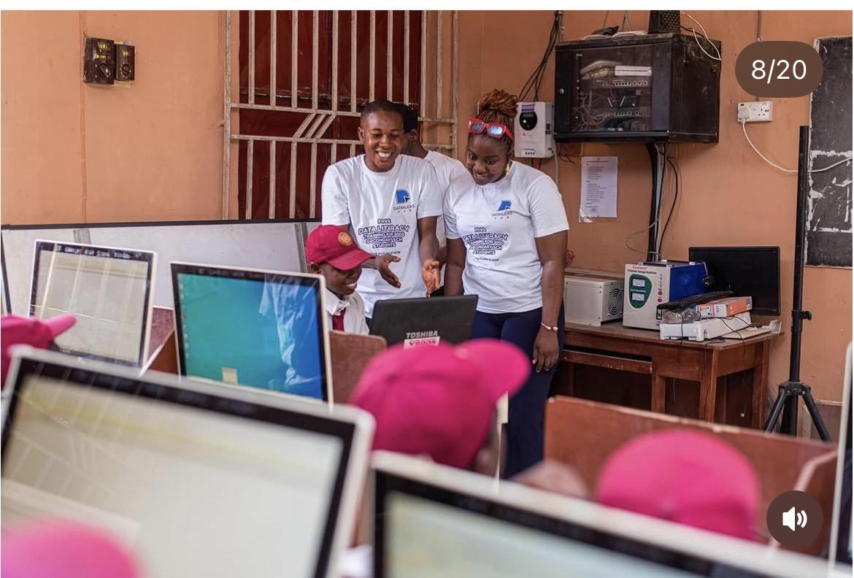
Headline: Taking Digital Skills Beyond the Classroom.
Subheadline: 3,000 Secondary School Students. One Digital Future.
Suggested copy:
In 2024, DataKlicks Hub began an initiative to introduce secondary school students to digital literacy and practical data skills. The initiative was publicly reported in February 2025, with a stated goal of reaching 3,000 students.
Through practical learning experiences, students are introduced to digital literacy, data awareness, Microsoft Excel, problem-solving and the possibilities that technology can create.
We believe digital education should not be reserved for people who can afford expensive training.
The earlier young people are introduced to technology, the more possibilities they can imagine for themselves.
CTA: Partner With Us on Our Impact Projects
The public record supports the initiative's launch and target. The website must distinguish students targeted from students actually trained and verified.
Tribune Online

Section 9: Women and girls in technology
Headline: Creating More Space for Women in Tech.
Copy:
DataKlicks Hub is committed to expanding access to technology education for women and girls. Through training, digital literacy initiatives, career development and community learning, we support more women in building practical skills and exploring opportunities in technology.
We don't just want more women in technology. We want more women building, leading and creating with technology.
Include authentic images from programs, where consent has been obtained.
CTA: Explore Our Impact

Section 10: Founder spotlight

Founder spotlight

Meet Elizabeth Gideon
Founder, DataKlicks Hub
Elizabeth Gideon is a data analyst, educator, business strategist and technology entrepreneur focused on helping individuals and businesses make better use of data, technology and digital skills.
Read Our Story →
Use an approved, authentic founder photograph rather than an AI-generated portrait. Link to the full About page and the founder's professional profile.

Section 11: Media and recognition
Headline: Our Work, Recognized.
Include a media logo grid or editorial cards for verified publications, interviews, features, awards and speaking engagements.
One confirmed starting point is the Tribune Online feature, “Akinyemi Elizabeth speaks on empowerment initiative for students,” published February 2, 2025.
Tribune Online
Each card must include:
- Publication or organization.
- Article or recognition title.
- Date.
- Short description.
- Link to the original source.
Do not publish fabricated publication logos, awards or endorsements.

Section 12: Testimonials and learner stories
Headline: Real People. Real Learning Journeys.
Display testimonials from verified learners, clients and partners.
Each testimonial should include:
- Name, with consent.
- Role or professional background, if approved.
- Course or program attended.
- Specific experience or outcome.
- Optional photograph.
- Source or verification record.
Do not invent testimonials or imply guaranteed employment, income increases or promotions.

Section 13: Latest from the blog
Show three recent articles with category, title, publication date, short excerpt and thumbnail.
CTA: Explore All Articles

Section 14: Final conversion section
Headline: Your Next Opportunity Starts With a Skill.
Supporting copy:
Whether you are building a career in data and AI or looking to improve how your business works, DataKlicks Hub is ready to help you take the next step.
Buttons:
- Explore Courses
- Talk to Our Team

Section 15: Footer
Use the global footer defined in Section 5.2.

7. Courses page
Route: /courses

7.1 Purpose
Help visitors discover the right learning program, understand what it offers and take an action to enroll or make an enquiry.

7.2 Page hero
Headline: Find the Skills That Move You Forward.
Subheading: Explore practical courses in data analytics, business intelligence, AI and digital skills, designed to help you learn, build and apply.
Include a search bar and course category filters.

7.3 Course discovery interface
Provide:
- Search by course name or skill.
- Filter by category.
- Filter by beginner, intermediate and advanced level.
- Filter by online, in-person or hybrid delivery.
- Filter by upcoming, open or self-paced availability.
- Sort by newest or alphabetical order.
Filters should update the displayed course cards without requiring a full page reload.

7.4 Course card design

Beginner-friendly
Example card

Data Analytics & AI
Build practical skills in data analysis, visualization, business problem-solving and the application of AI tools.
3 months · Example duration
Virtual · Example format
View Course Details
The duration and delivery details above are illustrative. Each published course must use its actual approved information.

7.5 Individual course detail page
Route: /courses/[slug]
Every course should have its own search-engine-indexable page.
Required sections:
- Course title and overview.
- Intended audience.
- Prerequisites.
- Learning outcomes.
- Curriculum and modules.
- Tools and technologies covered.
- Delivery method.
- Duration and schedule.
- Instructor profile.
- Projects and assessments.
- Course fee and payment options.
- Certificate details, if applicable.
- Frequently asked questions.
- Related courses.
- Enrollment or enquiry CTA.

Course enrollment workflow
- Visitor opens a course.
- Visitor reviews curriculum, schedule, prerequisites and fee.
- Visitor selects Enroll or Make an Enquiry.
- Visitor completes the enrollment form or proceeds to the approved registration/payment provider.
- The system displays a confirmation and sends an appropriate notification.
For the initial release, external registration and payment links are acceptable. Direct checkout, student accounts and a learning management system can be added later.

8. About Us page
Route: /about

8.1 Hero
Headline: Building a More Data-Literate and AI-Ready Africa.
Supporting copy:
DataKlicks Hub is a technology, education and business solutions company committed to equipping individuals and organizations with the skills, tools and knowledge required to thrive in a rapidly changing digital economy.
CTA: Explore Our Work

8.2 Our story
Use the following as the core draft:
DataKlicks Hub was founded in 2023 with a clear mission: to make practical data education more accessible and equip individuals with skills relevant to the changing world of work.
What began as a data analytics training startup focused on Microsoft Excel, Power BI, Tableau, SQL and Python has grown into a broader vision encompassing business analytics, artificial intelligence, automation, digital skills and business consulting.
Our approach goes beyond classroom instruction. We believe people learn best when they can practice, build, solve and apply.
That is why our learning experiences emphasize practical projects, real-world datasets, business scenarios and career preparation.
For organizations, we help turn data and technology into practical business value through training, analytics and consulting.
Today, our vision extends beyond individual skills development. We are working toward a future where more Africans can participate in the digital economy, build technology-driven careers and create solutions for the businesses and communities around them.

8.3 Mission, vision and values
Our Mission
To equip individuals and organizations with practical data, AI and digital skills that create opportunities and enable meaningful progress.
Our Vision
To help build a data-literate, AI-ready Africa where people and businesses can thrive through technology and innovation.
Our Values
Practical learning, accessibility, innovation, integrity, collaboration, inclusion and continuous growth.

8.4 Our evolution
Display a simple visual timeline.
|
Year
|
Milestone
|
| --- | --- |
|
2023
|
DataKlicks Hub founded.
|
|
2024
|
Digital literacy and data skills initiative launched with secondary school students.
|
|
2025
|
Publicly reported expansion of the initiative toward 3,000 students.
|
|
2026 onward
|
Continued expansion into data, AI education, automation and business solutions.
|
The timeline must distinguish completed milestones from targets, ongoing programs and future plans. Confirm dates and evidence before publication.

8.5 Founder and leadership

Elizabeth Gideon— Founder
Elizabeth Gideoni is a data analyst, educator, business strategist and technology entrepreneur focused on helping individuals and businesses make better use of data, technology and digital skills.
She founded DataKlicks Hub with a vision of making practical data education more accessible while creating pathways for people to develop relevant skills for the future of work.
Her professional journey spans banking, customer service, sales, data analytics, business strategy and entrepreneurship, bringing together technical understanding and business experience.
Her professional profile identifies services including training, business analytics, business consulting and public speaking.
LinkedIn
CTA: Connect With Elizabeth on LinkedIn
Link: https://ng.linkedin.com/in/akinyemi-elizabeth
Important content review: Confirm the final founder biography, preferred professional titles, qualifications and the spelling of the founder's full name. Do not publish “AI engineer” or other specialist credentials without confirming the exact qualification and preferred public description.

8.6 Our impact
Show the signature student initiative, women and girls in technology programs, community training and organizational partnerships.
Include supporting photographs, partner acknowledgements and links to media coverage.

8.7 Our team
Allow an expandable team section with:
- Name.
- Role.
- Short biography.
- Professional profile.
- Photograph.
Only include approved, current team members.

9. Blog page
Route: /blog

9.1 Purpose
Build organic search traffic, establish subject-matter authority, educate the community and create pathways to courses and business services.

9.2 Blog categories
- Data Analytics.
- Excel.
- Power BI.
- SQL.
- Python.
- Business Intelligence.
- Artificial Intelligence.
- Generative AI.
- Agentic AI.
- Automation.
- Business Strategy.
- Career Development.
- Digital Skills.
- Women in Technology.
- Company News and Impact.

9.3 Blog homepage layout
- Blog hero and search.
- Featured article.
- Category navigation.
- Latest articles grid.
- Popular or editor-selected articles.
- Newsletter signup.
- Pagination or Load More.

9.4 Blog article page
Route: /blog/[slug]
Each article must contain:
- Article title.
- Author.
- Publication date and last updated date.
- Estimated reading time.
- Featured image.
- Table of contents for longer posts.
- Article body.
- Relevant diagrams, examples or code.
- Sources and references where applicable.
- Related articles.
- Author profile.
- Relevant course or service CTA.
- Social sharing options.

Initial content ideas
- What Is Data Analytics? A Beginner's Guide.
- Excel vs Power BI: Which Should You Learn First?
- How Businesses Can Use Data to Make Better Decisions.
- A Beginner's Guide to SQL for Data Analysis.
- How AI Is Changing the Work of Data Analysts.
- Generative AI vs Agentic AI: Understanding the Difference.
- Practical AI Automations for Small Businesses.
- How to Build a Data Analytics Portfolio.
- Digital Literacy: Why It Matters for Secondary School Students.
- Women in Tech: Building Skills, Confidence and Opportunities.
Every article must be original, fact-checked and edited before publication. AI-assisted writing must receive human review.

9.5 Newsletter
Provide an optional email subscription form.
Fields:
- Email address.
- Optional first name.
- Consent checkbox where required.
Success message:
“Thank you for subscribing to DataKlicks Hub. Look out for practical insights, learning resources and updates from our community.”
Include unsubscribe functionality, consent records and privacy information.

10. Contact page
Route: /contact

10.1 Page hero
Headline: Let's Build Something That Matters.
Supporting copy:
Have a question about our courses, corporate training, business solutions or impact initiatives? Tell us what you need, and our team will get back to you.

10.2 Contact information
Email
dataklickshub@gmail.com
Instagram “https://www.instagram.com/dataklicks_hub?utm_source=ig_web_button_share_sheet&stkn=ZDNlZDc0MzIxNw==”
Facebook : “https://www.facebook.com/dataklickshub/”
Linkedin : “https://ng.linkedin.com/company/dataklicks-hub”

Location
Lagos, Nigeria

10.3 Contact form
The form must support multiple enquiry types.
Enquiry typeCourse enquiry
Full name
Email address
Organization (optional)
How can we help?
Prepare Enquiry
This demonstration prepares an enquiry message. The production website must connect the form to a secure submission service.

Production contact form requirements
The live implementation must:
- Validate all required fields.
- Validate email format.
- Use server-side validation.
- Include spam prevention and rate limiting.
- Send the enquiry to the appropriate team inbox.
- Store submissions securely if a CRM or database is used.
- Send a confirmation to the user.
- Display success and error states.
- Record consent where necessary.
- Never expose API keys or email service credentials in frontend code.
Recommended notification recipient: dataklickshub@gmail.com.

11. Functional requirements
The following requirements define the expected behavior of the production website.
|
ID
|
Requirement
|
Priority
|
| --- | --- | --- |
|
FR-01
|
Responsive navigation and footer
|
Must have
|
|
FR-02
|
Home page with hero, services and impact
|
Must have
|
|
FR-03
|
Dynamic course catalog
|
Must have
|
|
FR-04
|
Individual course detail pages
|
Must have
|
|
FR-05
|
Course enquiry or enrollment links
|
Must have
|
|
FR-06
|
About page and founder profile
|
Must have
|
|
FR-07
|
Blog listing and article pages
|
Must have
|
|
FR-08
|
Functional contact form
|
Must have
|
|
FR-09
|
CMS for courses and blog content
|
Must have
|
|
FR-10
|
SEO metadata and social sharing metadata
|
Must have
|
|
FR-11
|
Privacy, terms and cookie controls
|
Must have
|
|
FR-12
|
Newsletter subscription
|
Should have
|
|
FR-13
|
Search and filters for courses
|
Should have
|
|
FR-14
|
Analytics and conversion tracking
|
Should have
|
|
FR-15
|
Student login and LMS
|
Future phase
|
|
FR-16
|
Online checkout and course payments
|
Future phase
|
|
FR-17
|
Personalized learning dashboard
|
Future phase
|
|
FR-18
|
AI learning assistant
|
Future phase
|

12. Content management system
The website should allow authorized team members to manage content without editing code.

Required CMS collections
Courses
- Course name.
- Slug.
- Category.
- Short description.
- Full description.
- Thumbnail.
- Learning outcomes.
- Curriculum.
- Level.
- Duration.
- Delivery mode.
- Instructor.
- Price and currency.
- Registration URL.
- Start date.
- Enrollment status.
- Featured status.
- SEO title and description.
Blog posts
- Title.
- Slug.
- Excerpt.
- Body.
- Author.
- Category.
- Featured image.
- Publication date.
- Last updated date.
- SEO metadata.
- Draft or published status.
Testimonials
- Name.
- Role.
- Testimonial.
- Related course or service.
- Image, if approved.
- Consent status.
- Publication status.
Impact stories
- Project name.
- Location.
- Date.
- Target audience.
- Number reached.
- Outcome measures.
- Partner organizations.
- Supporting evidence.
- Images and consent records.

CMS permissions
- Administrator: full access.
- Editor: manage and publish approved content.
- Author: create and edit assigned drafts.
- Analyst: access reporting, where supported.
Require secure authentication and appropriate access controls.

13. Recommended technology stack
The implementation should prioritize performance, maintainability, security, search visibility and ease of content management.
Frontend — Next.js + TypeScript
Responsive, component-based development, reusable layouts, server rendering and SEO-friendly pages.
Styling — Tailwind CSS
Consistent design tokens, responsive utilities and reusable components.
CMS — Sanity or a comparable headless CMS
Manage courses, blog articles, impact stories and team content through an editorial interface.
Database — PostgreSQL or managed equivalent
Use for structured submissions and future platform functionality when required.
Email — Transactional email provider
Contact notifications, confirmation emails and newsletter integration.
Hosting — Vercel or equivalent
Production deployment, HTTPS, preview environments and automated builds.

Alternative implementation
If the team needs a more accessible editing experience and a faster launch, WordPress with a well-supported block-based theme and a restrained plugin stack is a valid alternative.
The choice should be made based on the available developer, budget, content workflow and future platform requirements. Do not introduce a custom student portal or complex backend into the first release unless it is necessary.

14. Non-functional requirements

14.1 Responsive design
The website must work across:
- Mobile phones: 320px and above.
- Tablets: approximately 768px and above.
- Laptops: approximately 1024px and above.
- Large desktop screens: 1440px and above.
Layouts must adapt rather than simply shrink. No horizontal overflow, clipped text or inaccessible navigation.

14.2 Performance
Target the following Core Web Vitals at the 75th percentile of real-user visits:
|
Metric
|
Target
|
| --- | --- |
|
Largest Contentful Paint (LCP)
|
≤ 2.5 seconds
|
|
Interaction to Next Paint (INP)
|
≤ 200 milliseconds
|
|
Cumulative Layout Shift (CLS)
|
≤ 0.1
|
Additional requirements:
- Optimize and compress images.
- Use modern image formats where supported.
- Lazy-load below-the-fold imagery.
- Avoid unnecessary JavaScript.
- Minimize render-blocking resources.
- Use caching and a CDN.
- Avoid autoplay video with sound.
- Reserve image dimensions to prevent layout shifts.

14.3 Accessibility
Target WCAG 2.2 Level AA.
Requirements include:
- Semantic HTML.
- Keyboard-accessible navigation and forms.
- Visible keyboard focus.
- Correct heading hierarchy.
- Text alternatives for meaningful images.
- Accessible form labels and error messages.
- Sufficient color contrast.
- Reduced-motion support.
- Captions or transcripts for meaningful video content.
- Accessible mobile menus and interactive elements.

14.4 Security
- Enforce HTTPS.
- Keep secrets and API credentials server-side.
- Validate and sanitize submitted data.
- Apply spam protection and rate limiting.
- Use secure authentication for CMS access.
- Restrict administrator permissions.
- Keep dependencies and plugins updated.
- Configure backups and recovery procedures.
- Establish a process for security incidents.
- Avoid collecting unnecessary personal information.

14.5 Privacy and compliance
Because the business operates in Nigeria and may serve international visitors, the site must be designed with applicable data protection obligations in mind.
Requirements:
- Publish an understandable privacy policy.
- Explain what personal data is collected and why.
- Document retention and deletion practices.
- Obtain appropriate consent for marketing communications.
- Provide unsubscribe functionality.
- Assess third-party analytics and cookie use.
- Disclose relevant third-party services.
- Provide a channel for privacy-related requests.
The final privacy and cookie arrangements should be reviewed against applicable Nigerian requirements, including the Nigeria Data Protection Act, and other relevant jurisdictions where the business operates.

15. SEO and digital discoverability

15.1 SEO objectives
- Rank for relevant data analytics and AI training searches.
- Increase organic discovery of courses.
- Attract corporate training and consulting enquiries.
- Establish authority in practical data education.
- Make impact initiatives discoverable by potential partners.

15.2 Suggested keyword themes
- Data analytics training in Nigeria.
- Data analytics courses in Lagos.
- Power BI training in Nigeria.
- Microsoft Excel training.
- SQL training for beginners.
- Business intelligence training.
- AI training in Nigeria.
- Generative AI training.
- AI automation for businesses.
- Corporate data analytics training.
- Data analytics consulting.
- Digital literacy initiatives in Nigeria.
These are target keyword themes, not claims about search volume or current ranking.

15.3 Technical SEO
The website must include:
- Unique page titles and meta descriptions.
- Canonical URLs.
- XML sitemap.
- Robots.txt.
- Open Graph and social sharing metadata.
- Descriptive image alt text.
- Clean, readable URLs.
- Internal linking.
- Breadcrumbs on course and article pages.
- Redirects for changed URLs.
- Structured data where appropriate.
- Google Search Console integration.
Use relevant structured data types, such as Organization, Article, BreadcrumbList and Course, only when the visible page content meets the applicable requirements. Do not publish fabricated ratings or reviews through structured data.

15.4 Suggested homepage metadata
SEO title: DataKlicks Hub | Data Analytics, AI Training & Business Solutions
Meta description: Build practical skills in data analytics, business intelligence and AI with DataKlicks Hub. Explore professional training, corporate solutions and digital impact initiatives.
Suggested homepage H1: Building Africa’s Next Generation of Data and AI Professionals.

16. Analytics and conversion tracking
The website should provide measurable insight into how visitors discover the brand and take action.

Track the following events
- page_view
- course_list_view
- course_detail_view
- course_search
- course_filter_used
- enrollment_cta_click
- course_enquiry_submit
- contact_form_submit
- business_enquiry_submit
- newsletter_signup
- blog_article_view
- impact_partnership_click
- social_link_click

Reporting dashboard
The team should be able to monitor:
- Total website visitors.
- Traffic sources.
- Most visited pages.
- Popular courses.
- Course enquiry conversion rate.
- Contact form conversion rate.
- Business enquiry volume.
- Newsletter subscriptions.
- Mobile versus desktop engagement.
- Organic search performance.
Use a privacy-conscious analytics configuration and ensure tracking respects applicable consent requirements.

17. Content governance and credibility
This is a critical requirement for DataKlicks Hub's public reputation.
The supplied information includes both verified historical context and figures that require internal confirmation.
|
Content claim
|
Publication requirement
|
| --- | --- |
|
Founded in 2023
|
Confirm against company records.
|
|
5,000+ people trained or impacted
|
Reconcile training and impact records; define what “impacted” means.
|
|
3,000 students
|
Distinguish the target from the verified number trained.
|
|
80%+ women
|
Confirm the denominator, reporting period and source records.
|
|
Media features
|
Link to the original publication.
|
|
Awards and recognition
|
Verify the award, recipient, date and awarding organization.
|
|
Corporate clients
|
Obtain permission to display client names and logos.
|
|
Learner testimonials
|
Obtain consent and verify the statement.
|
|
AI and technical credentials
|
Confirm the founder's and team's qualifications.
|
|
Job placements and income outcomes
|
Maintain supporting records and define the measurement period.
|
Important: A target, estimate, cumulative reach figure and verified outcome are not interchangeable. The website should use precise labels such as “trained,” “reached,” “registered,” “targeted” and “impacted” according to the underlying evidence.

18. Acceptance criteria
The website is ready for launch when all critical requirements below are satisfied.

Launch readiness checklist
0/17
All five primary pages are complete and accessible.
The site uses consistent royal blue, white and approved brand typography.
Header, mobile navigation and footer work across screen sizes.
Course cards and individual course pages display accurate information.
Course enrollment and enquiry links lead to the correct destinations.
The About page includes the approved company story and founder biography.
The blog supports categories, article pages and publication metadata.
The contact form validates submissions and delivers messages to the designated inbox.
Impact statistics and media claims have been verified and approved.
SEO metadata, sitemap, robots.txt and canonical URLs are configured.
Accessibility testing covers keyboard navigation, forms and contrast.
Performance testing meets the agreed Core Web Vitals targets or documents exceptions.
HTTPS, backups, access controls and spam protection are configured.
Privacy policy, terms and required consent mechanisms are published.
Analytics events are tested and functioning.
The production domain and all social links have been verified.
The site has been tested on current mobile and desktop browsers.
Reset checklistCopy checklist

19. Project phases and delivery plan
A practical delivery plan is six weeks, subject to team capacity, content readiness and integrations.
Phase 1 — Discovery and content
Week 1
Finalize scope, brand assets, content inventory, course catalog, verified statistics and technical requirements.
Phase 2 — UX and visual design
Week 2
Produce wireframes, mobile layouts, design system, homepage design and reusable page components.
Phase 3 — Development
Weeks 3–4
Build the website, CMS, course catalog, article templates, contact form and responsive interactions.
Phase 4 — QA and content loading
Week 5
Test functionality, content, SEO, accessibility, security and performance.
Phase 5 — Launch
Week 6
Deploy to the production domain, verify tracking, submit the sitemap and monitor the first weeks of activity.

20. Launch deliverables
The project should deliver:
- A complete, responsive website.
- Five fully implemented primary pages.
- Individual course detail page template.
- Blog listing and article templates.
- CMS setup and editorial access.
- Functional contact and newsletter integrations.
- Verified company, founder and impact content.
- SEO and analytics configuration.
- Privacy and legal pages.
- Production deployment and domain configuration.
- Testing and launch documentation.
- Basic content editing and website maintenance guide.

21. Future roadmap
The initial website should be built to accommodate future expansion without requiring a complete redesign.
Phase 2 — DataKlicks Academy
Student accounts, course progress, recorded lessons, assignments, certificates, instructor dashboards and a learning management system.
Phase 3 — Online enrollment and payments
Secure checkout, payment confirmation, enrollment records, receipts and supported Nigerian and international payment methods.
Phase 4 — AI-powered learning
AI-assisted learning resources, guided practice, course recommendations and learning support with appropriate privacy and accuracy controls.
Phase 5 — Corporate learning portal
Corporate accounts, team enrollment, training requests, organizational dashboards and program reporting.

22. Final implementation brief for the development team

Build the DataKlicks Hub digital experience
Create a premium, internationally presentable, responsive website for DataKlicks Hub, a Nigerian technology, education and business solutions company founded in 2023.
The website must use royal blue and white as its core brand colors, with modern typography, clean layouts, professional imagery, subtle animations and a strong emphasis on usability, credibility and conversion.
Build the five primary pages: Home, Courses, About Us, Blog and Contact. Include reusable course detail and blog article templates, an editable CMS, functional enquiry forms, search-engine optimization, accessibility, analytics and security.
The home page must feature a compelling hero, animated impact statistics, service categories, featured courses, the company's learning methodology, business solutions, its secondary-school digital literacy initiative, women-in-tech initiatives, founder profile, verified media features, testimonials and strong calls to action.
Position the company as both a practical learning destination for aspiring data and AI professionals and a solutions partner for businesses seeking analytics, automation, training and consulting.
Use authentic company and founder assets wherever possible. Make the site mobile-first, fast, accessible and easy for the internal team to maintain.
All claims, statistics, awards, testimonials, partnerships, credentials, course prices and enrollment details must be verified before publication. Build the first release as a polished corporate and education website, with the architecture ready for future student accounts, online payments and an AI-powered learning platform.

23. Reference links and research
The following public sources provide starting points for the company's existing digital presence and public record:
- DataKlicks Hub — existing website
- DataKlicks Hub on LinkedIn
- Elizabeth Akinyemi on LinkedIn
- Tribune Online — student digital skills initiative
The public company profile identifies DataKlicks Hub as founded in 2023 and describes its original focus on data analytics and business analysis education.
LinkedIn
The Tribune report provides external context for the student initiative.
Tribune Online
Final recommendation for implementation: Treat this PRD as the master product specification. Before design begins, finalize the logo and exact brand color, approve the founder biography, reconcile the impact figures, confirm the active course catalog and registration links, and collect authentic photographs and media references. These are the main inputs needed to turn the specification into a production-ready website without publishing inaccurate information.

